**CMPE 206 – Computer Network Design**

**Lab 2**

First Name: **Harish**

Last Name: **Marepalli**

SJSU ID: **016707314**

Professor: **Yalda Edalat**

**Table of Contents**

**1. Understand the Mechanism of Link-State Routing Protocol Open Shortest Path First (OSPF)**

**2. Configure Router with Loopback Address**

**3. Configure Router with OSPF and LSAs Message Sending**

**4. Configure Router with OSPF LSAs Message Suppression**

**5. Configure Router with OSPF Reference Bandwidth**

**6. Configure Router with OSPF Route Cost on interfaces**

**7. Configure Router in OSPF Multi-Area Environment**

**8. Configure Area Border Router with Route Summarization**

**9. Conclusion**

**Task1: Understand the Mechanism of Link-State Routing Protocol Open Shortest Path First (OSPF):**

**Quiz:**

1A: Routers R5, R6, R7, R8, R9, R10, R11, and R12 are IRs. These routers have all interfaces in the same area.

1B: Routers R2, R3, and R4 are ABRs. These three routers have interfaces in two separate areas. So, they are ABRs.

1C: Routers R1, R2, R3, and R4 are BRs. These 4 routers are backbone routers because they all have at least one interface in the backbone area (Area 0).

1D: Router R1 is ASBR. This router connects the OSPF network to the internet (external network), and likely advertises a default route into the OSPF domain.

1E: No, it is not valid because it is not a correct OSPF design and will cause problems because Area 1 does not have an ABR connected to the backbone area, Area 0. All OSPF areas must have at least one ABR connected to the backbone area, if we connect R2 to R3, then R2 will be disconnected from the backbone area.

1F: No, it is non-contiguous. OSPF interfaces in the same subnet must be in the same area. Instead of all being connected, half of area of 1 is to the left most and another half is to the right most. This kind of network design is not allowed in OSPF and will cause problems.

2. **B** (Signal-area OSPF must use area 0), **F** (The OSPF process ID must match the area number).

For B: Although, it is common practice to use Area 0 for single-area OSPF, we can actually use any area.

For F: The OSPF process ID does not have to match the area number. In fact, in multi-area OSPF, there will be multiple areas operating in a single process. So, it is impossible to match the process ID to all area IDs. The other statements are all true.

3. **C** (R1(config-router)# network 10.0.12.0 0.0.1.255 area 0).

This is the only option that contains both IP addresses in its range. So, it is the only one that activates OSPF on both interfaces.

Option A: It is not correct because it only covers from 10.0.12.1 to 10.0.12.254 (i.e., 10.0.12.0/24) which is G0/1 only.

Option B: It is not correct because the wildcard mask itself is not valid.

Option D: It is not the correct option because it only covers from 10.0.8.1 to 10.0.11.254 (i.e., 10.0.8.0/22) which is neither G0/1 nor G0/2.

4. **B** (R1(config)# ip route 0.0.0.0 0.0.0.0 203.0.113.2

R1(config)# router ospf 1

R1(config-router)# default-information originate).

The correct option is B, which configures a default route and then advertises it into OSPF using the default-information originate command.

Option A simply configures two network commands which activates OSPF on the specified interfaces.

Option C activates OSPF on all interfaces with an IP address, since all IP addresses match 0.0.0.0/0.

Option D is not a real command.

5. **A**. The correct answer is A, router-id 1.1.1.1, entered in OSPF configuration mode. The command to manually configure the EIGRP router ID is eigrp router-id, but for OSPF it is just 'router-id'.

Option C configures an IP address on a loopback interface. If the router ID is not manually configured, this IP address might become the OSPF routerID, but it is different than manually configuring the router ID.

6. Down -> Init -> 2-way -> Exstart -> Exchange -> Loading -> Full.

7. **C** (Fast Ethernet, Gigabit Ethernet, and 10 Gigabit Ethernet interfaces have the same cost.). Option C is the correct answer. As the default cost is 100Mbps (which is Fast Ethernet interface bandwidth), and the cost less than 1 is converted to 1, the Fast Ethernet, Gigabit Ethernet, and 10 Gigabit Ethernet has the same cost which is 1.

Cost = Ref. Bandwidth / Interface Bandwidth

Cost (FaEth) = 100Mbps / 100Mbps = 1

Cost (GigaEth) = 100Mbps / 1000Mbps = 1

Cost (10 GigaEth) = 100Mbps / 10000Mbps = 1

8. **C** (R1(config-router)# auto-cost reference bandwidth 10000). Option C is correct because this command can be used to make a fast ethernet interface have an OSPF cost of 100.

Cost (FaEth) = 10000Mbps / 100Mbps = 100.

9. **B**. The default OSPF hello and dead timers are 10sec and 40sec respectively.

**Task 2: Configure Router with Loopback Address:**

Performed all the steps for configuring router with loopback address.

a. Screenshot for R1.

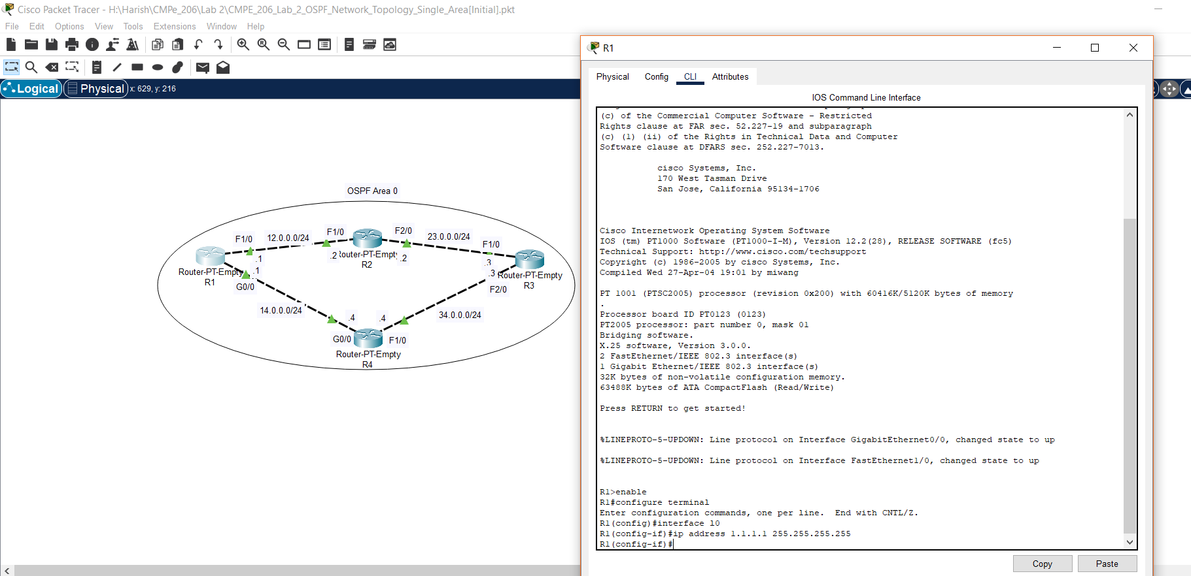

b. Screenshot for R2.

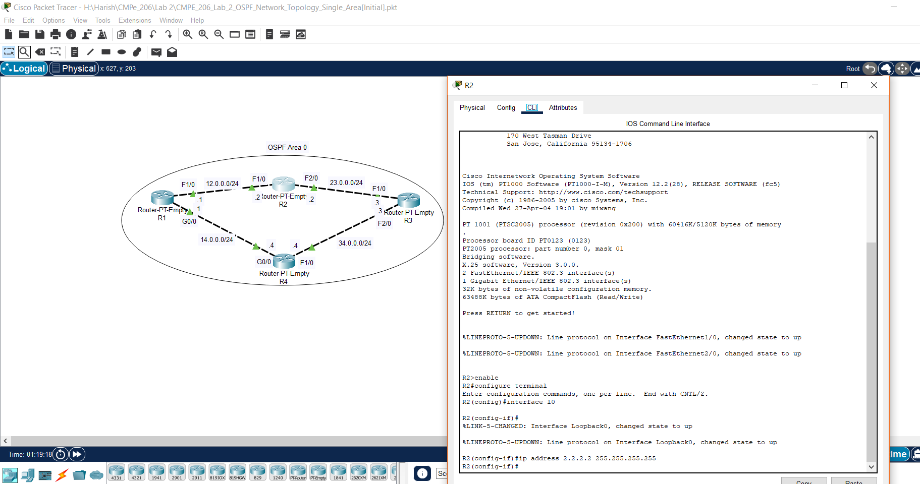

c. Screenshot for R3.

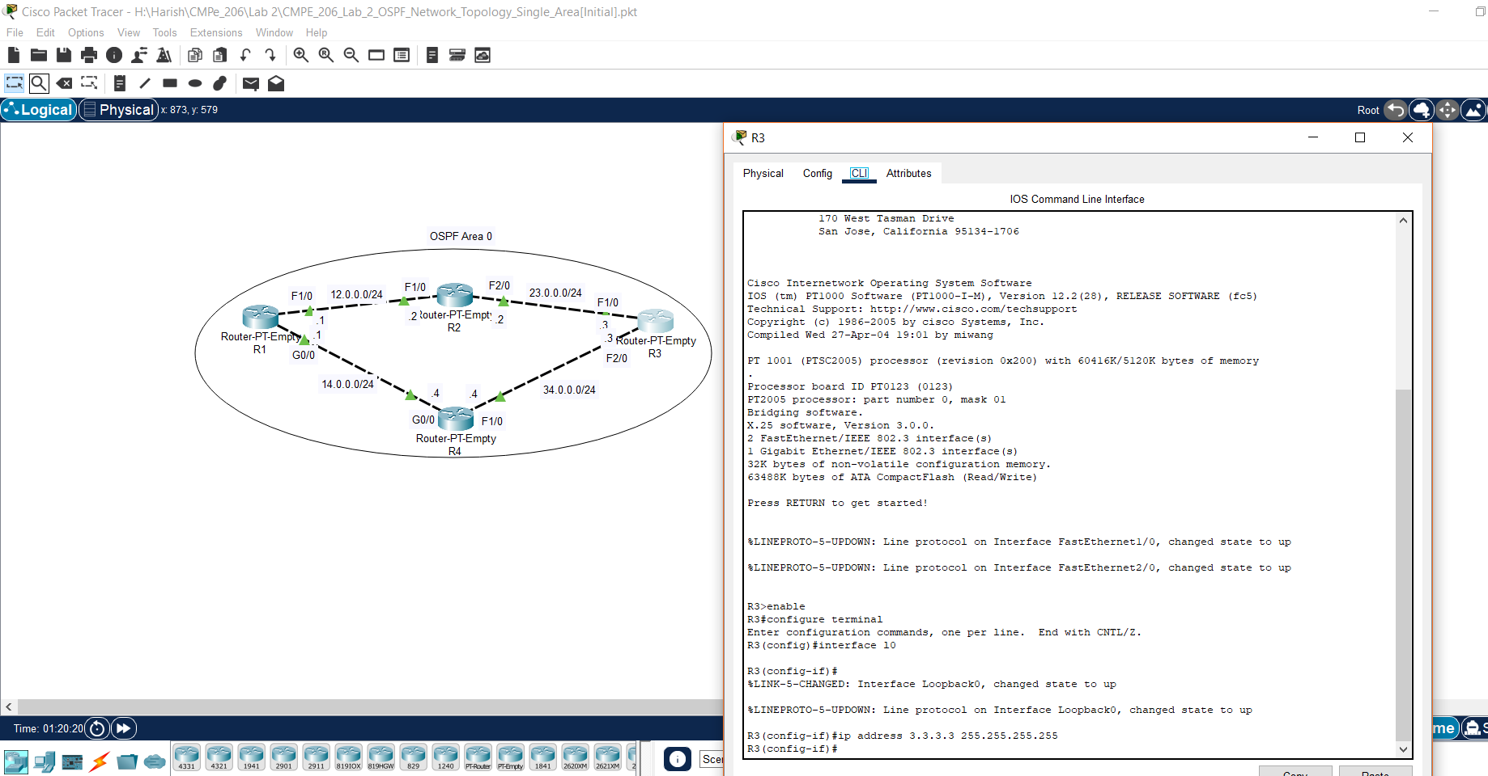

d. Screenshot for R4.

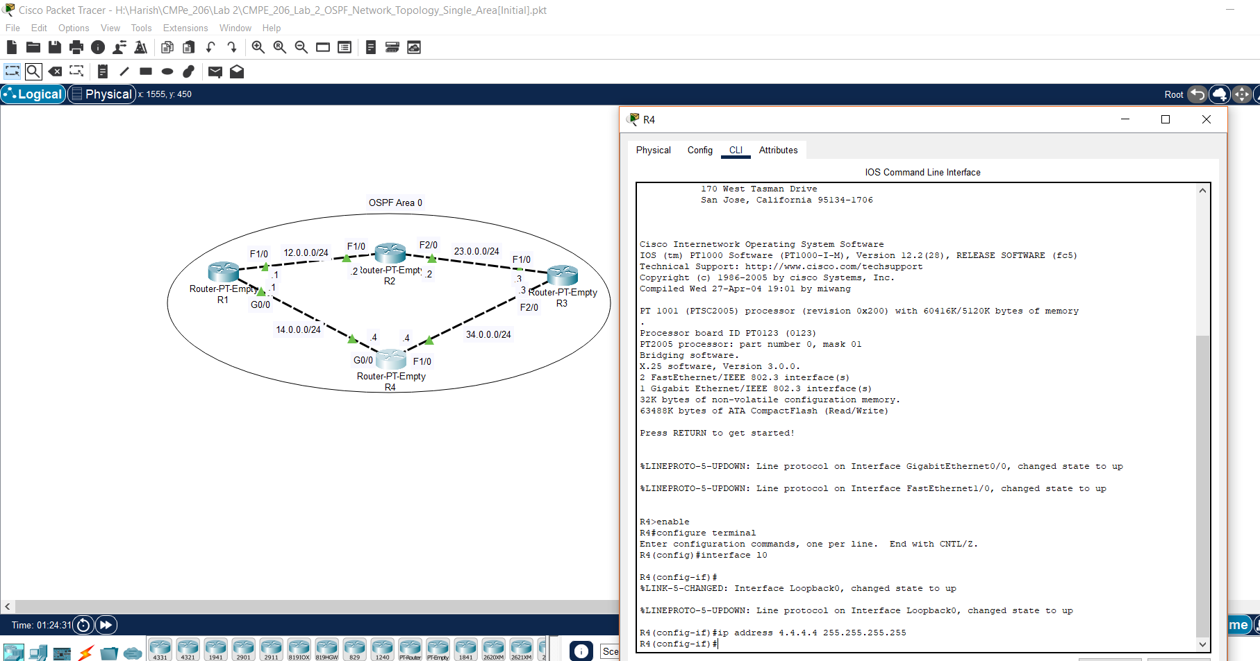

**Task3: Configure Router with OSPF and LSAs Message Sending:**

Performed all the steps for configuring router with OSPF and LSAs message sending.

a. Screenshot for configuring R1 with OSPF and enabling LSAs message sending.

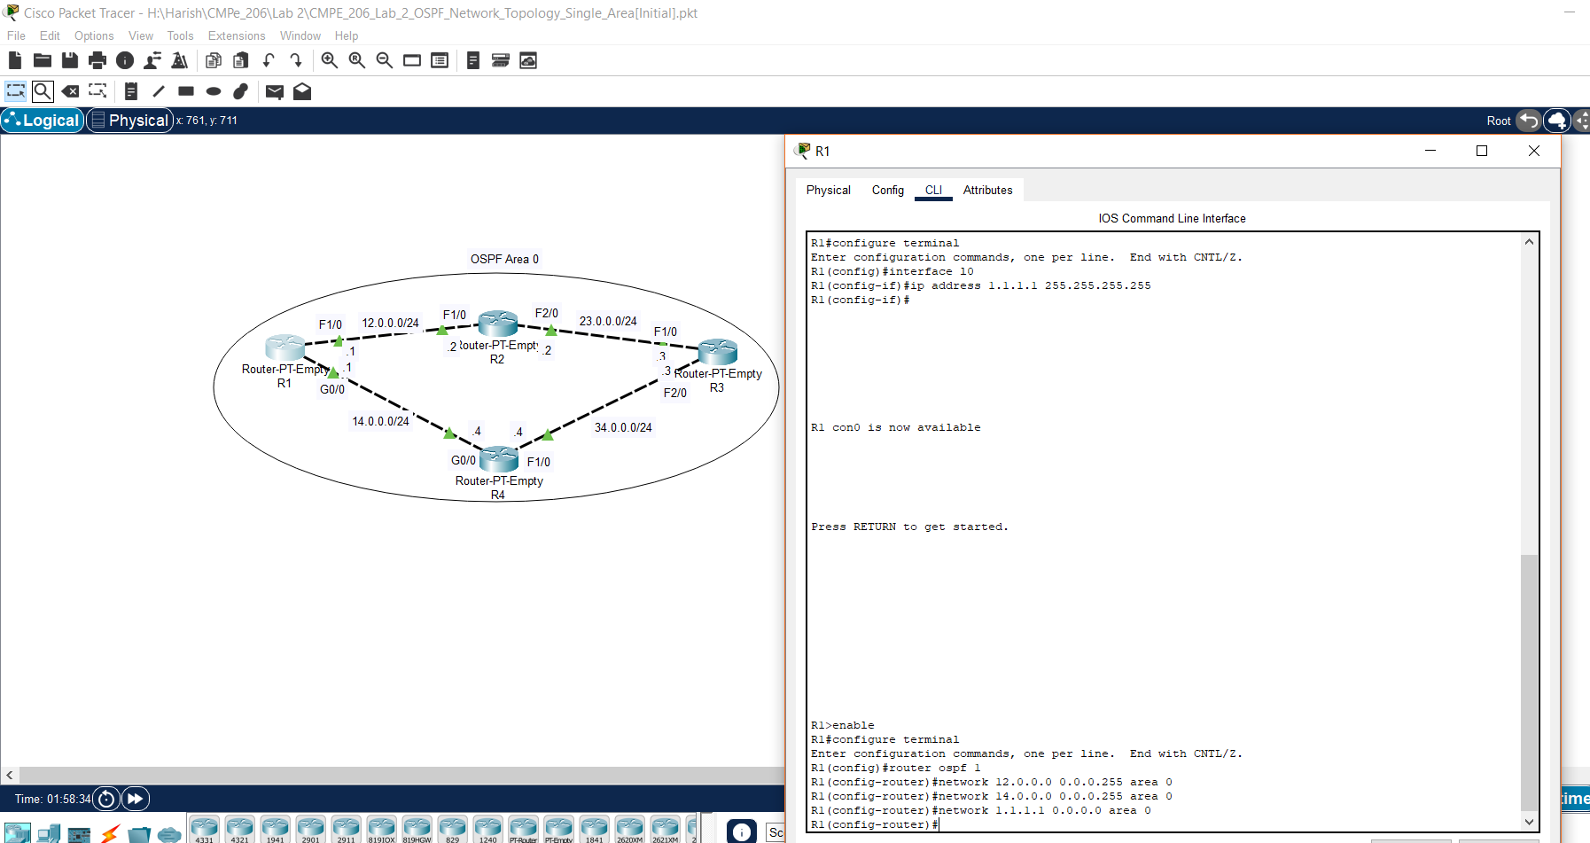

b. Screenshot for configuring R2 with OSPF and enabling LSAs message sending.

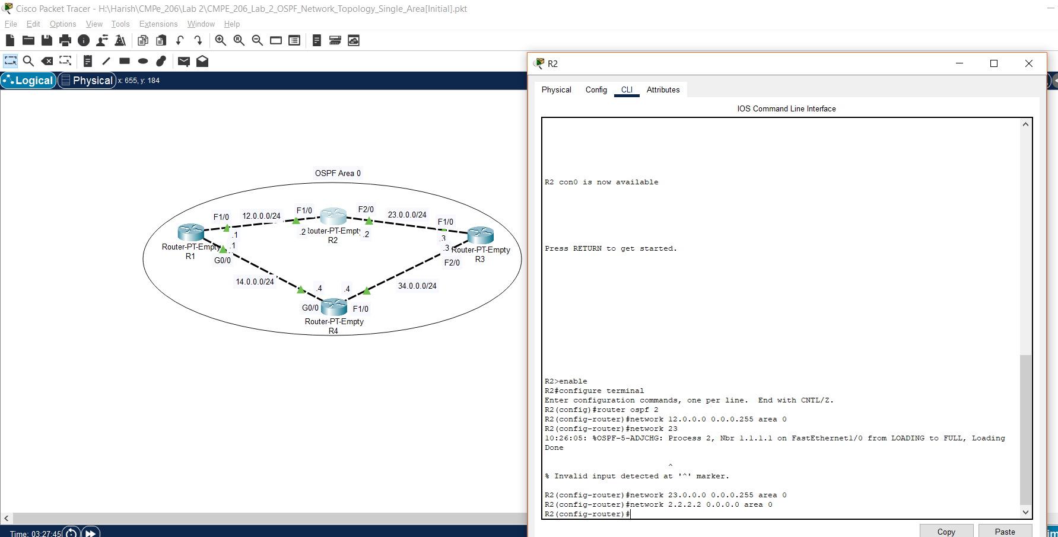

c. Screenshot for configuring R3 with OSPF and enabling LSAs message sending.

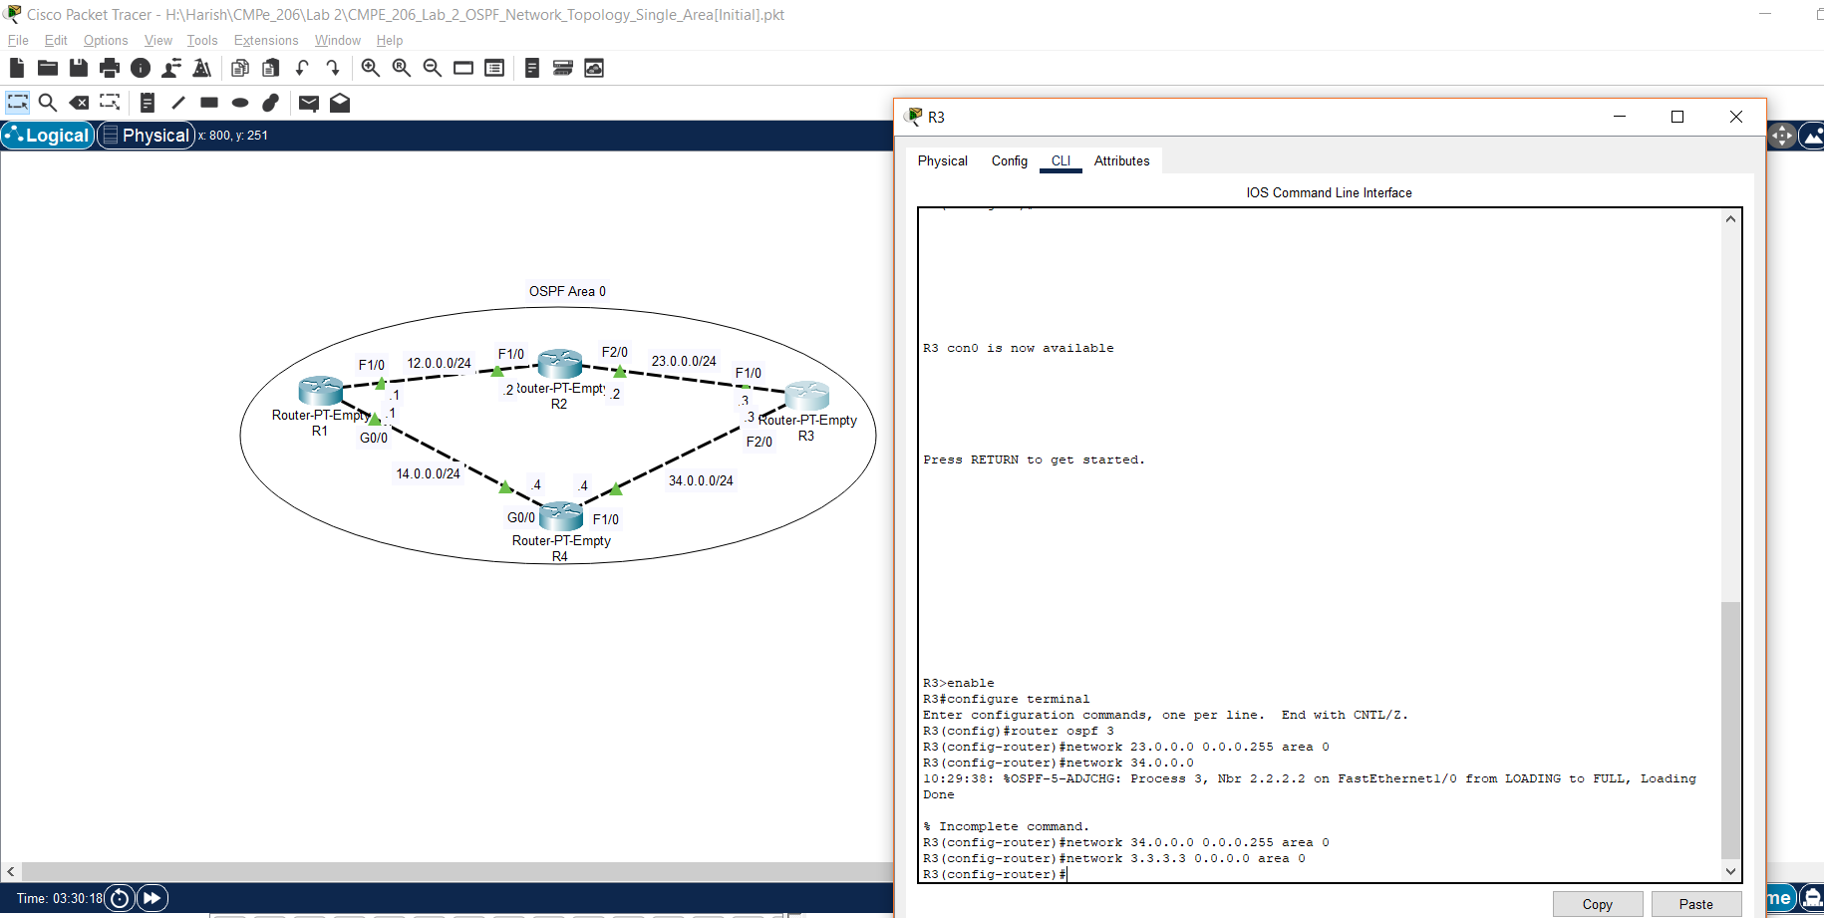

d. Screenshot for configuring R4 with OSPF and enabling LSAs message sending.

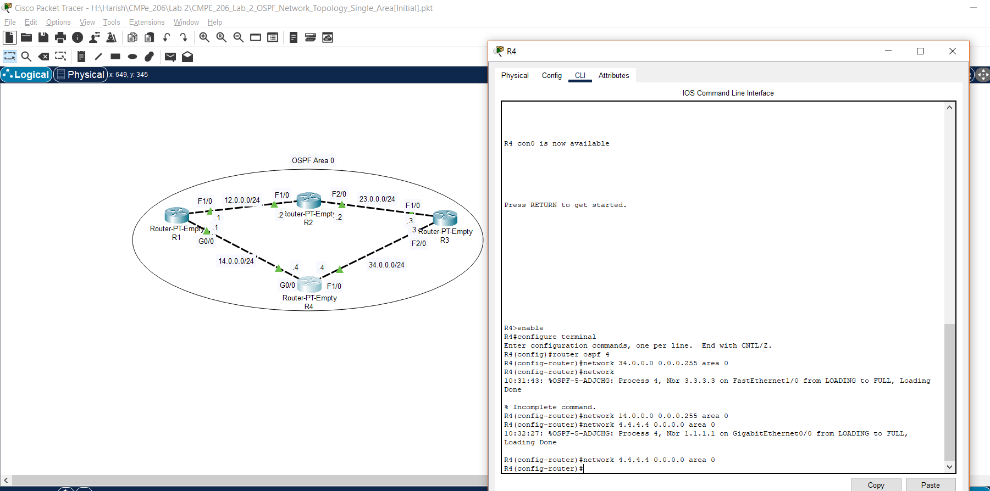

e. Screenshot for examining the current OSPF neighbor and route information for R1.

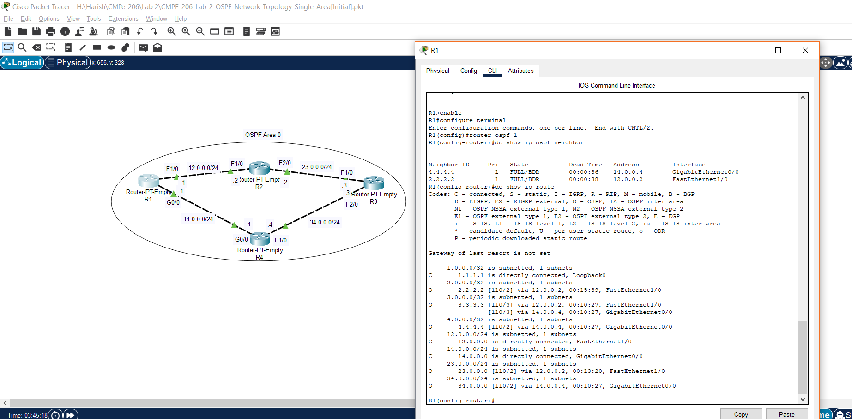

f. Screenshot for examining the current OSPF neighbor and route information for R2.

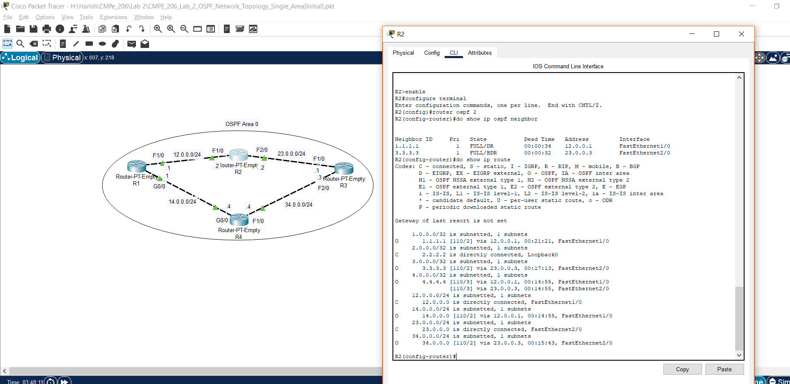

g. Screenshot for examining the current OSPF neighbor and route information for R3.

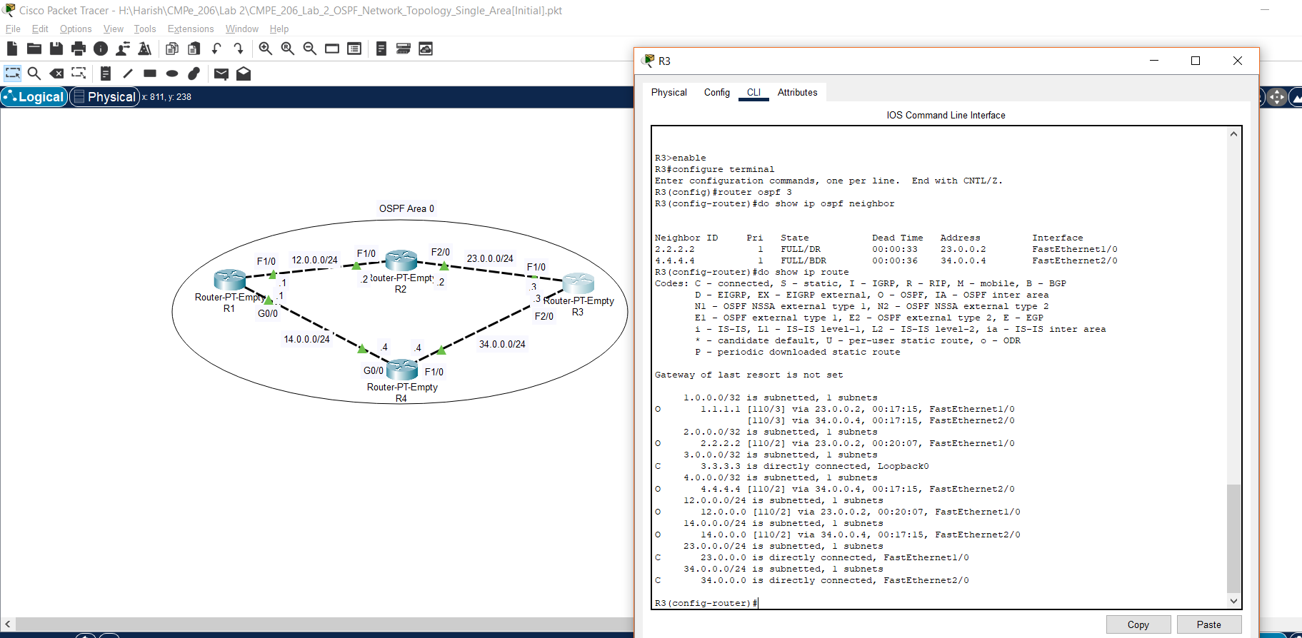

h. Screenshot for examining the current OSPF neighbor and route information for R4.

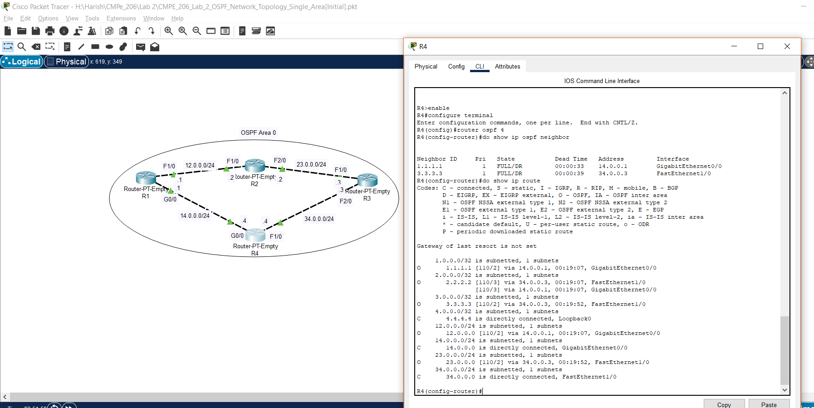

**Task 4: Configure Router with OSPF LSAs Message Suppression:**

Performed all the steps for configuring router with OSPF LSAs message suppression.

a. Screenshot for R1.

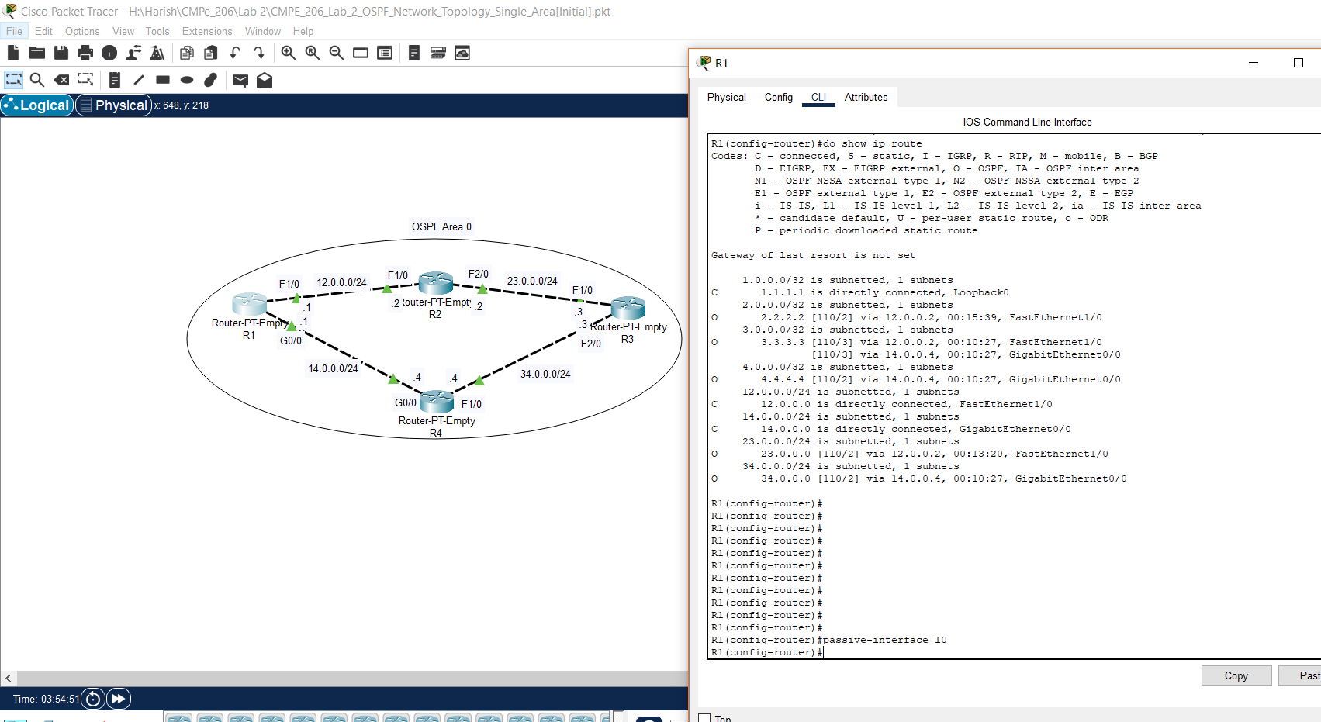

b. Screenshot for R2.

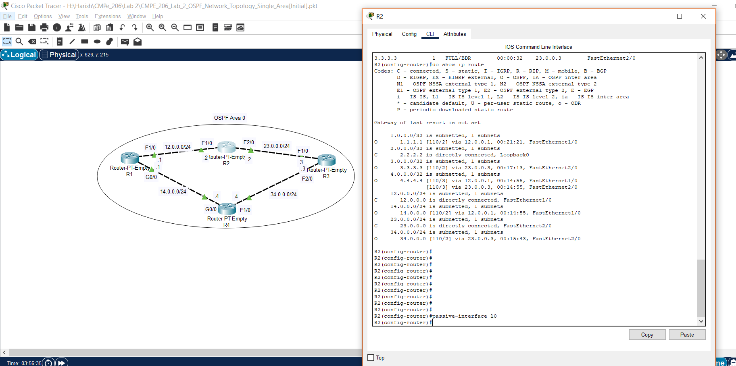

c. Screenshot for R3.

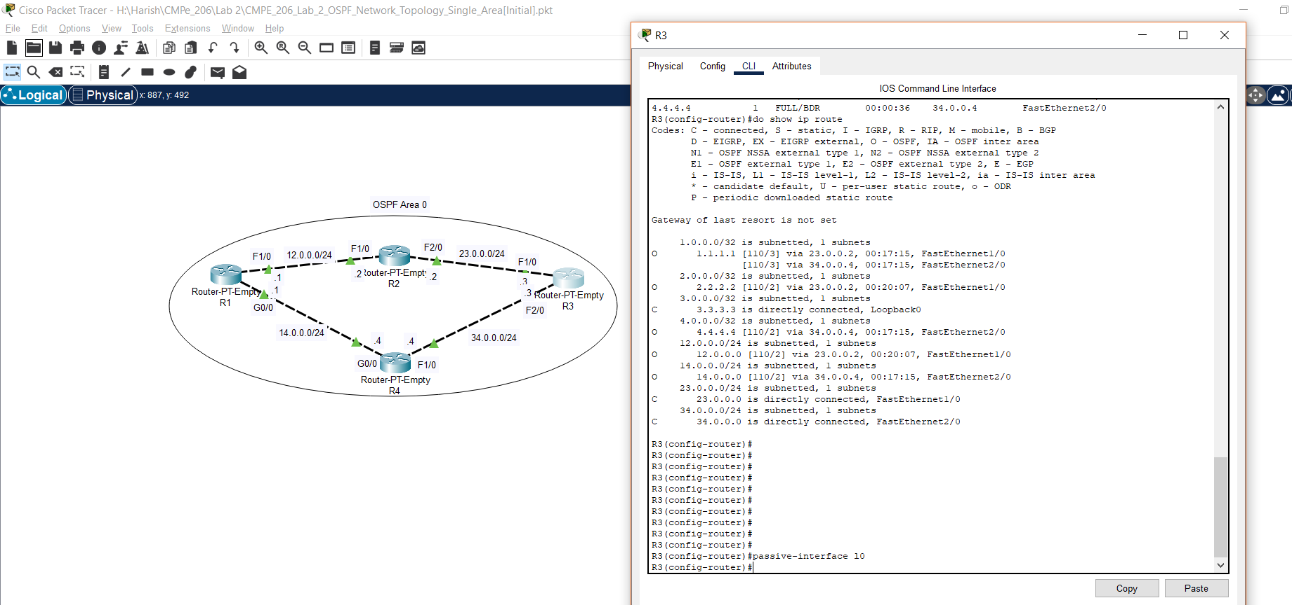

d. Screenshot for R4.

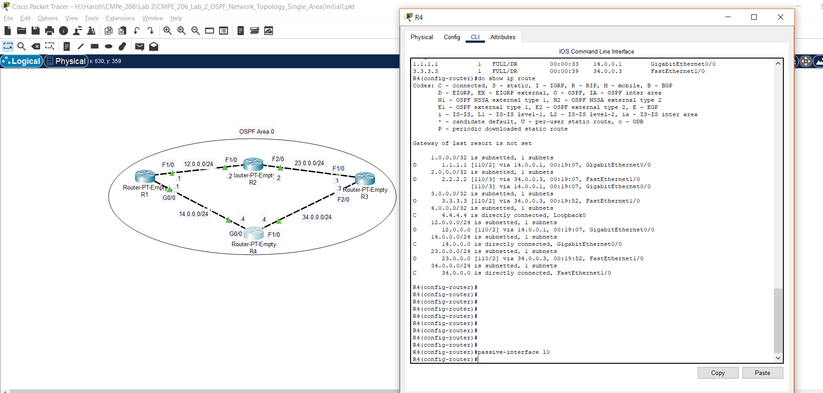

**Task 5: Configure Router with OSPF Reference Bandwidth:**

Performed all the steps for configuring router with OSPF reference bandwidth.

1. There is an issue with the current reference bandwidth. Say we are sending a message from R1 to R3, then according to the routing info of R1, there are two possible ways to reach R3 even though one of them is a Gigabit Ethernet Interface. Since, the reference bandwidth is default set to 100Mbps, the cost of higher interface will be 1.

The below screenshot shows the same where R1 to R3 has two possibilities.



So, the routes that we can take to forward messages from R1 to R3 are:

3.3.3.3 [110/3] via 12.0.0.2, 00:10:27, FastEthernet1/0

[110/3] via 14.0.0.4, 00:10:27, GigabitEthernet0/0

We can say that there should be only GigabitEthernet0/0.

1b. R1 has two different interfaces with one being FastEthernet1/0 and other being GigabitEthernet0/0, yet they both have same cost. The reason is that the cost is calculated based on the reference bandwidth (Default = 100Mbps) that is already been set.

Cost of FastEthernet1/0 = Ref. Bandwidth / Interface Bandwidth = 100Mbps / 100Mbps = 1

Cost of GigabitEthernet0/0 = Ref. Bandwidth / Interface Bandwidth = 100Mbps / 1000Mbps = 1 (Since cost values less than 1 will be converted to 1)

Therefore, both costs are same.

1c. To fix the issue, the default reference bandwidth needs to be changed to the highest interface bandwidth.

2. a. Screenshot for fixing the wrong bandwidth issue in the network for R1.

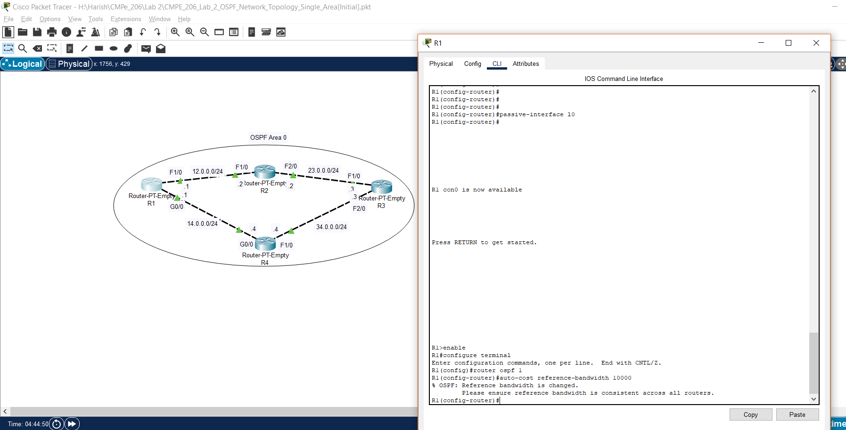

b. Screenshot for fixing the wrong bandwidth issue in the network for R2.

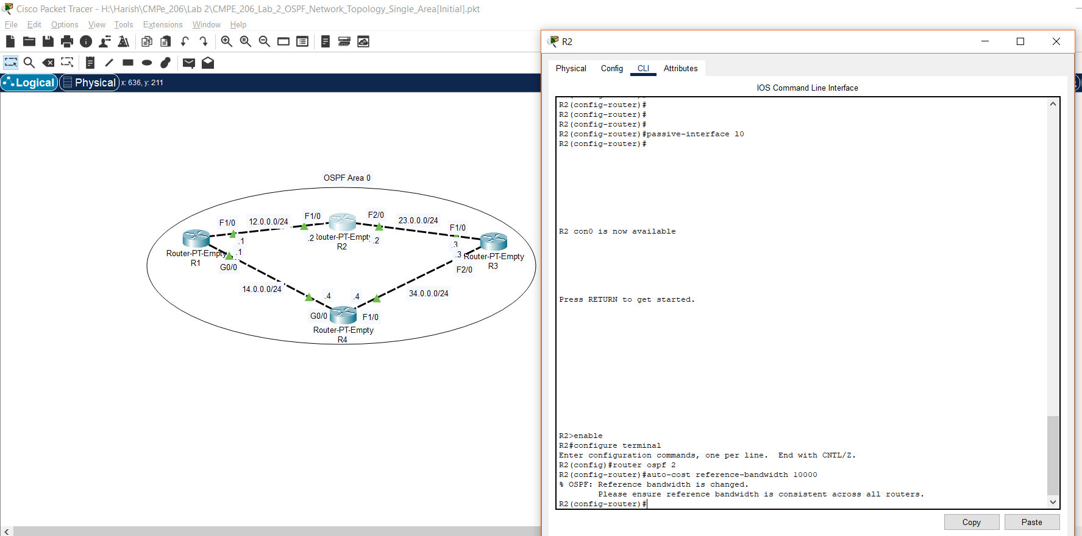

c. Screenshot for fixing the wrong bandwidth issue in the network for R3.

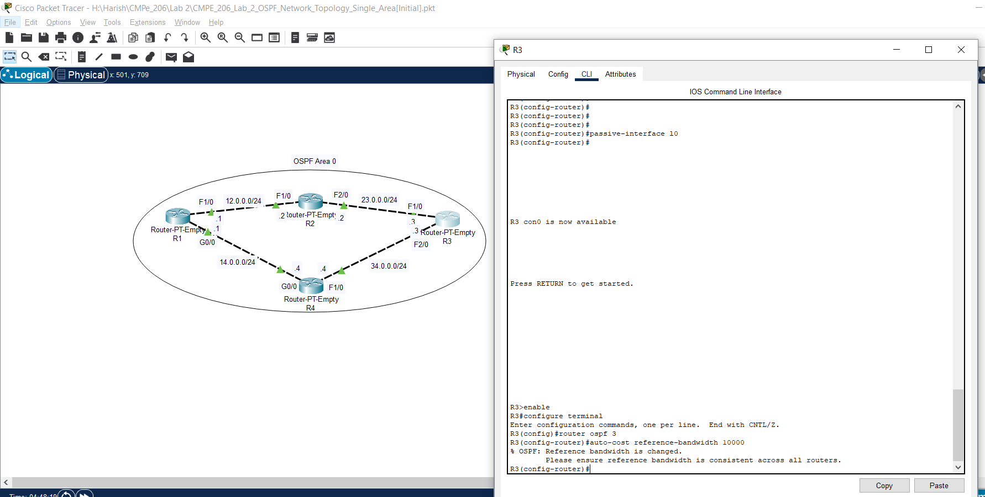

d. Screenshot for fixing the wrong bandwidth issue in the network for R4.

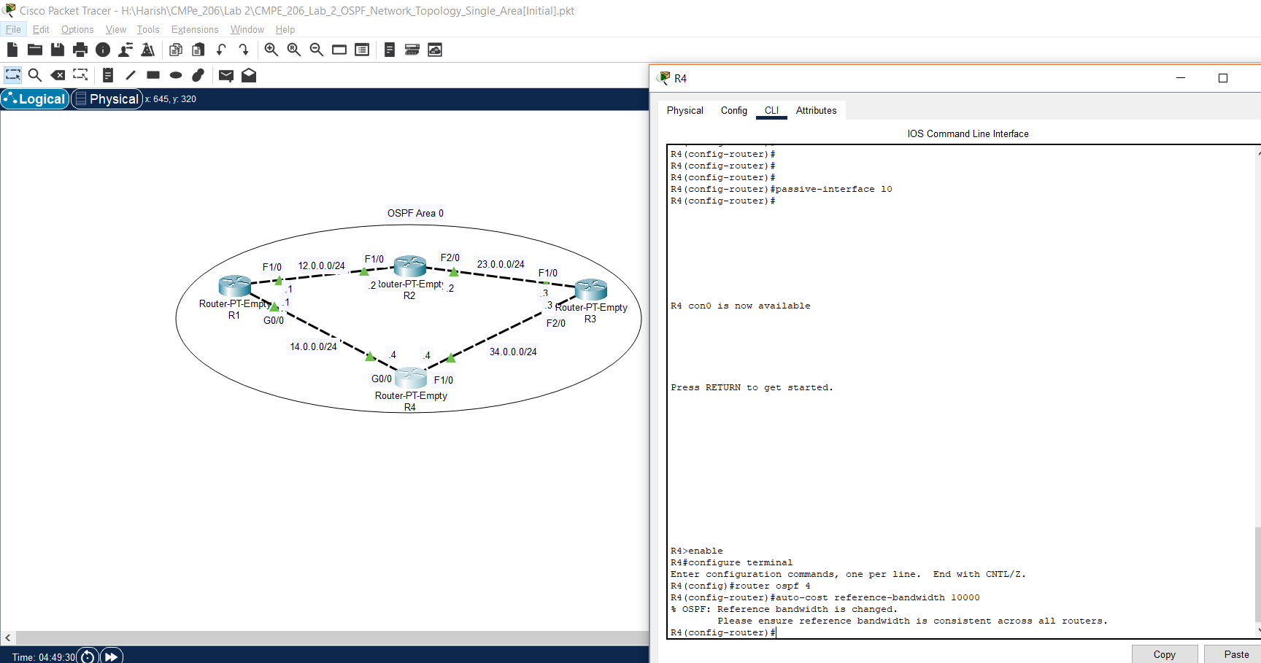

e. Screenshot of R1 for checking if it only uses the best route to forward message to R3.

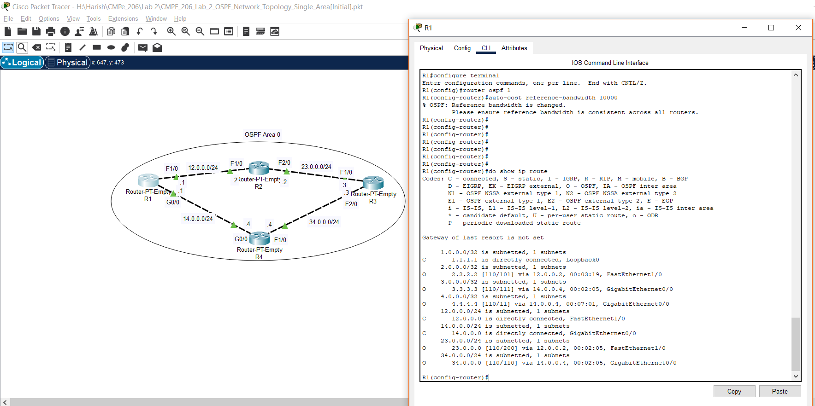

**Task 6: Configure Router with OSPF Route Cost on interfaces:**

Performed all the steps for configuring router with OSPF route cost on interfaces.

a. Screenshot to adjust OSPF interface cost for R1.

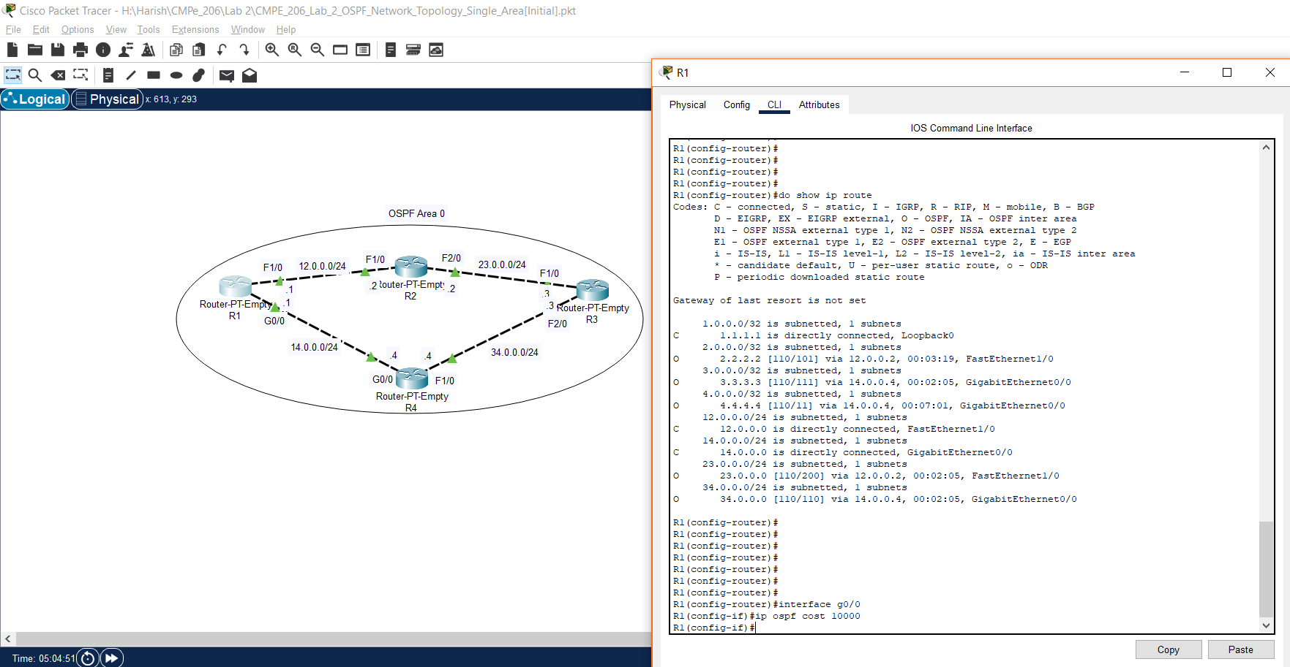

b. Screenshot to adjust OSPF interface cost for R4.

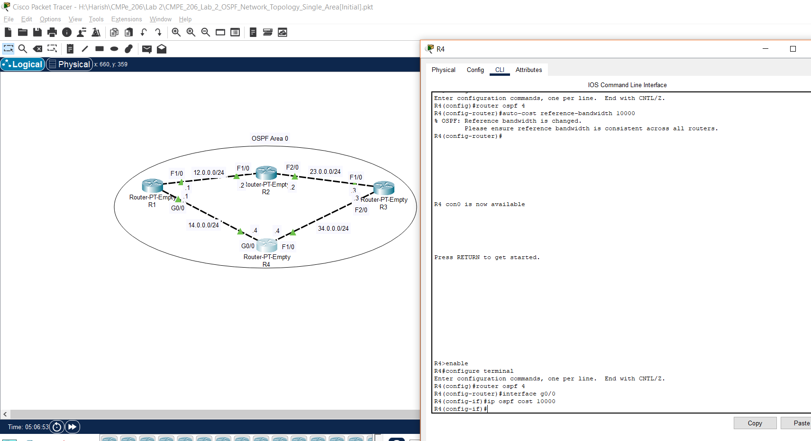

c. Screenshot for R1 to check if it uses the best route to forward message to R3.

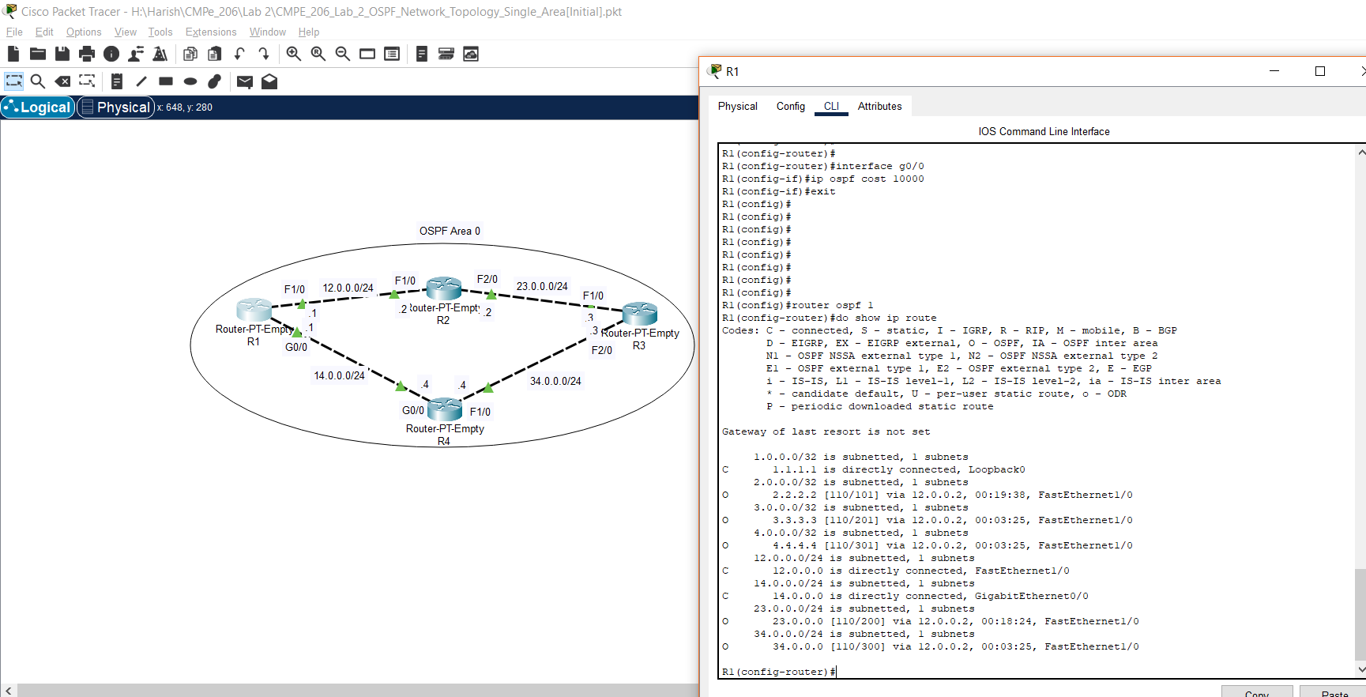

Here, there is this line 3.3.3.3 [110/201] via 12.0.0.2, 00:03:25, FastEthernet1/0. So, it shows the message to R3 now goes through R2.

**Task 7: Configure Router in OSPF Multi-Area Environment:**

Performed all the steps for configuring router in OSPF multi-area environment.

a. Screenshot for configuring R1 in OSPF Multi-Area environment.

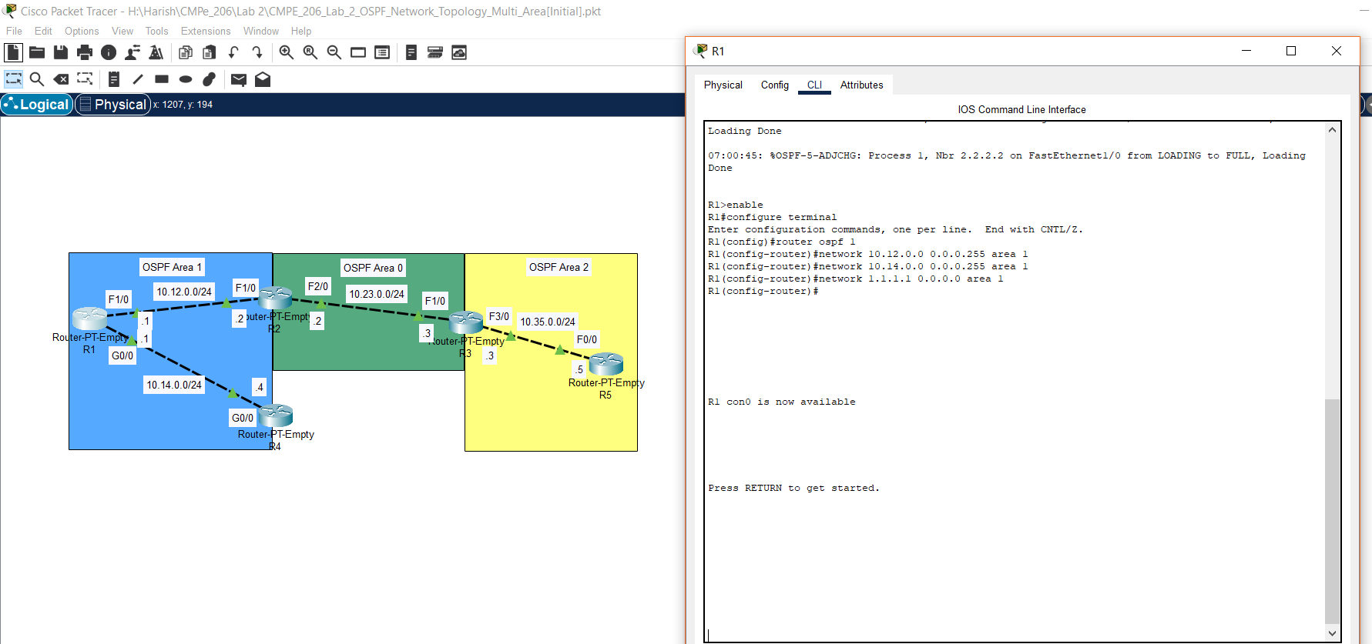

b. Screenshot for configuring R2 in OSPF Multi-Area environment.

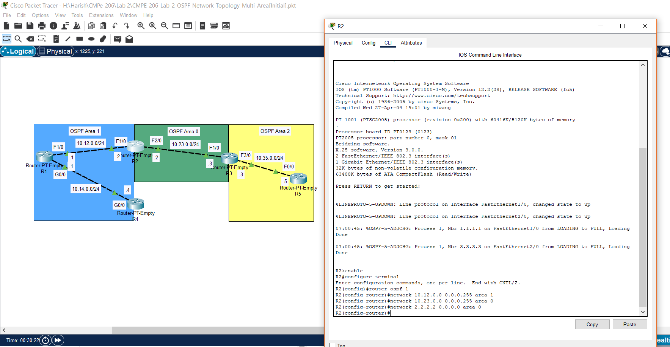

c. Screenshot for configuring R3 in OSPF Multi-Area environment.

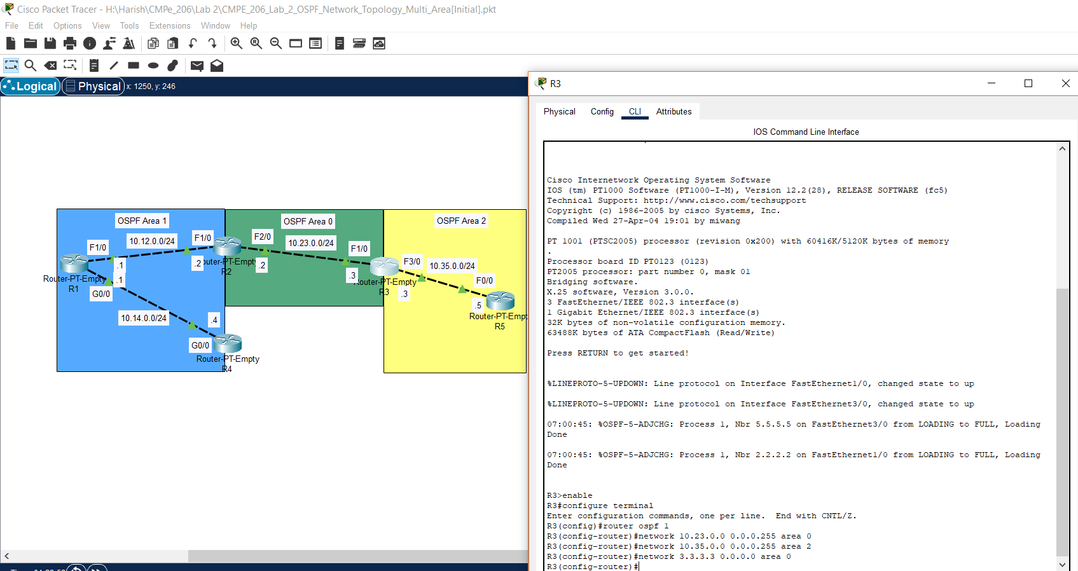

d. Screenshot for configuring R4 in OSPF Multi-Area environment.

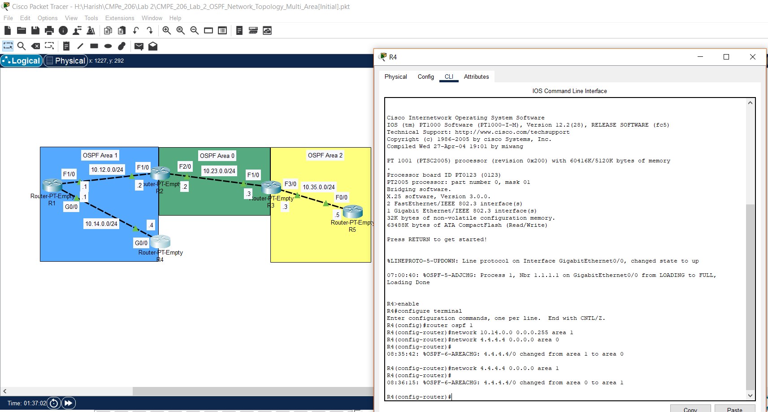

e. Screenshot for configuring R5 in OSPF Multi-Area environment.

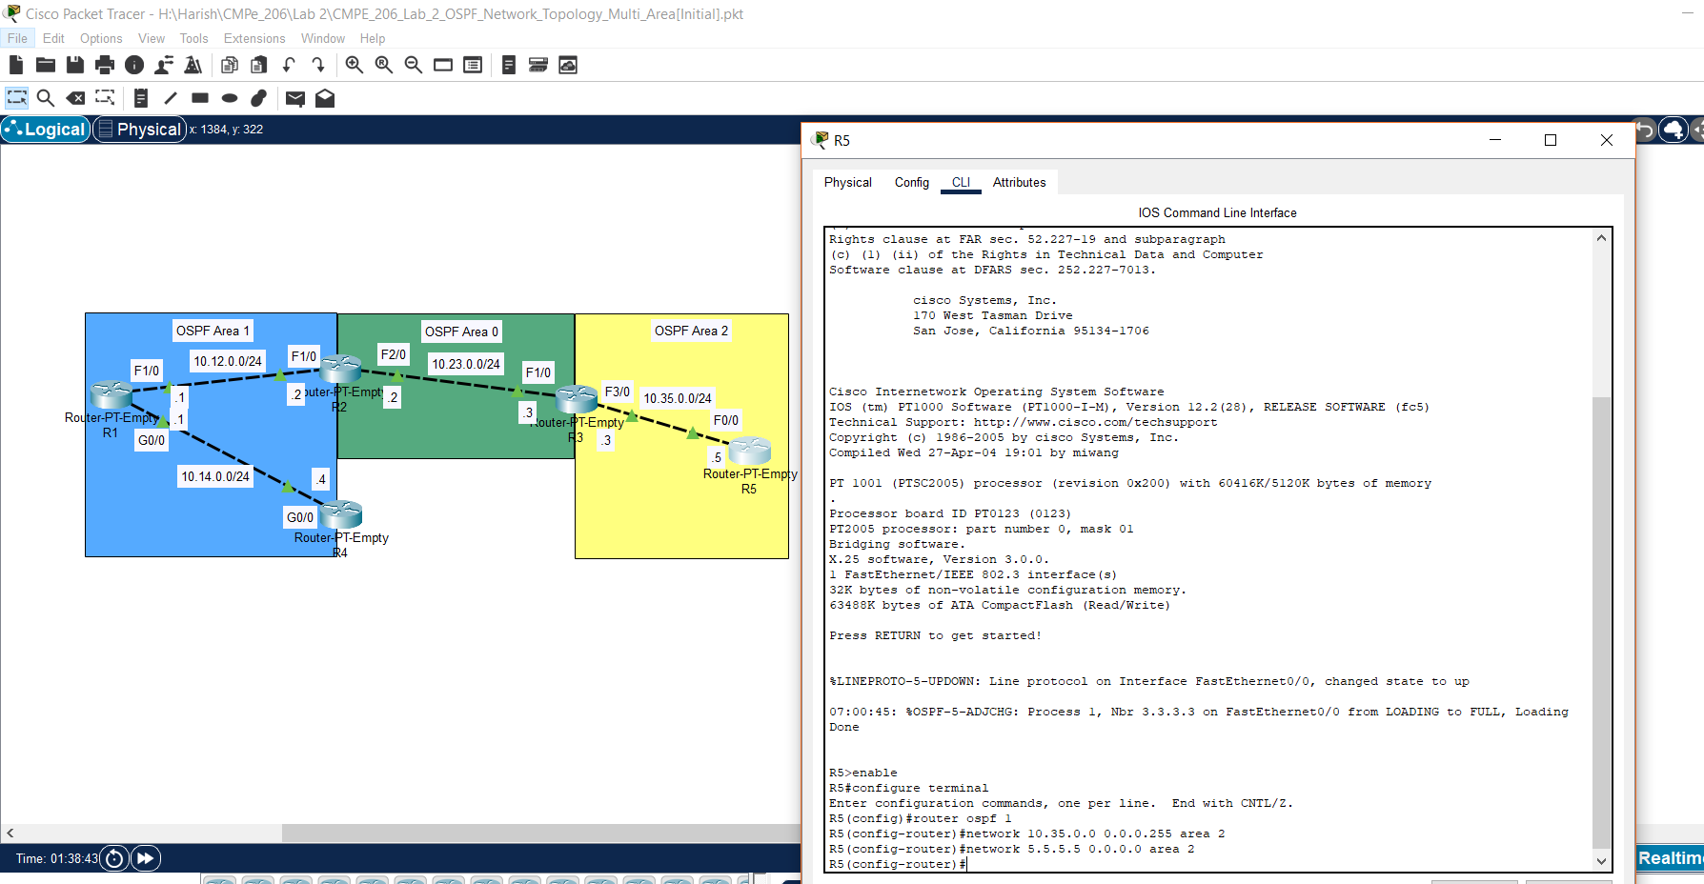

f. Screenshot of R1 for turning loopback interface from active to passive and configuring the proper bandwidth number.

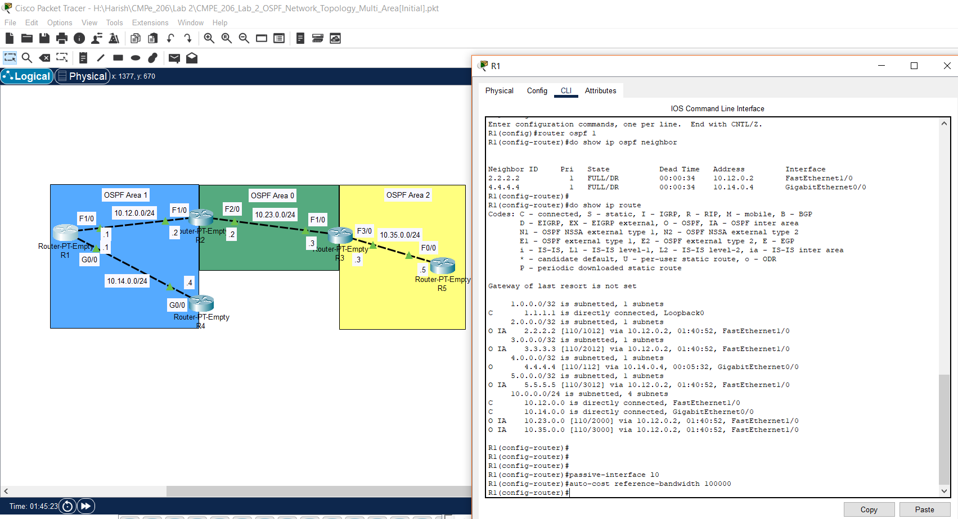

g. Screenshot of R2 for turning loopback interface from active to passive and configuring the proper bandwidth number.

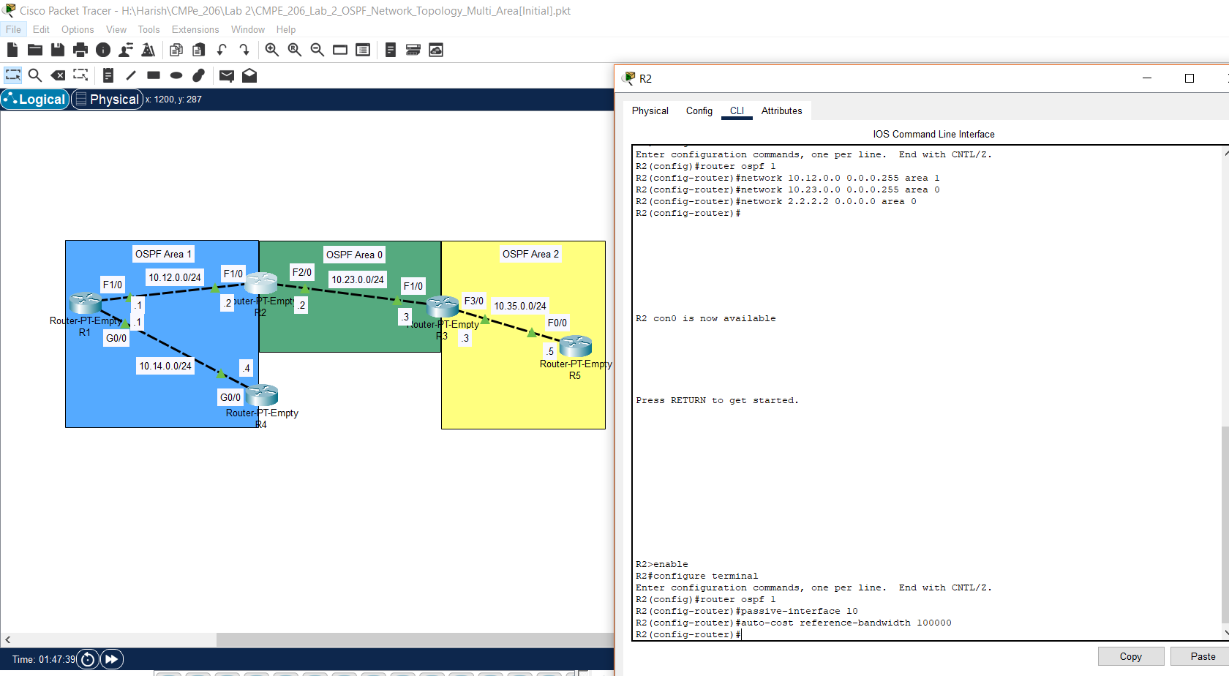

h. Screenshot of R3 for turning loopback interface from active to passive and configuring the proper bandwidth number.

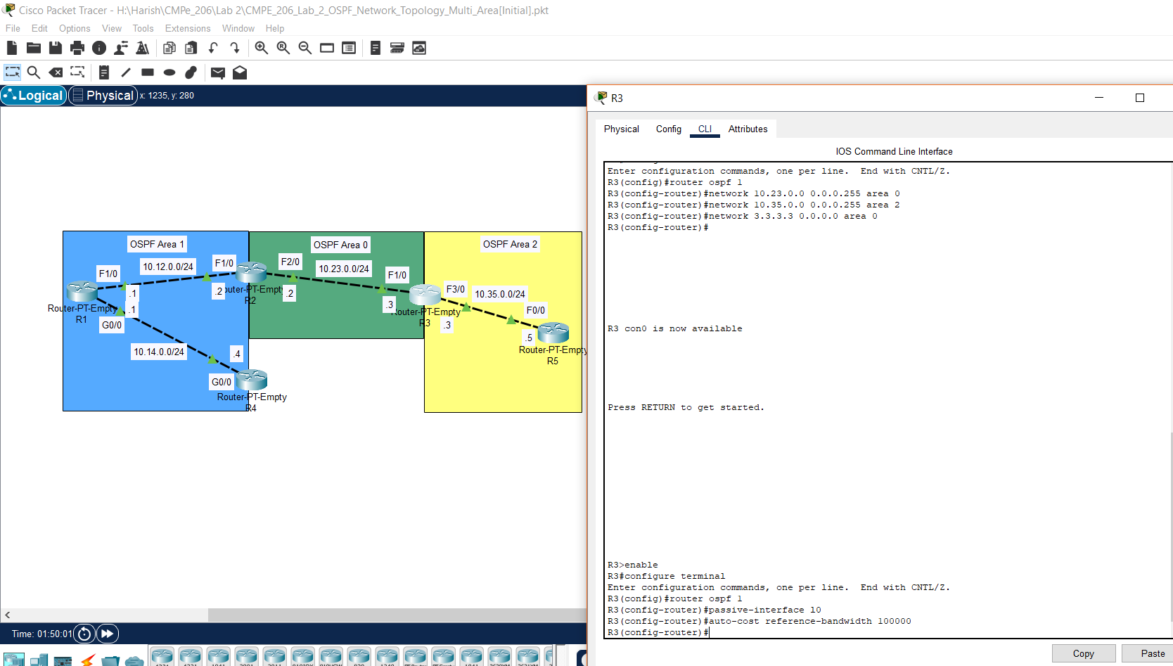

i. Screenshot of R4 for turning loopback interface from active to passive and configuring the proper bandwidth number.

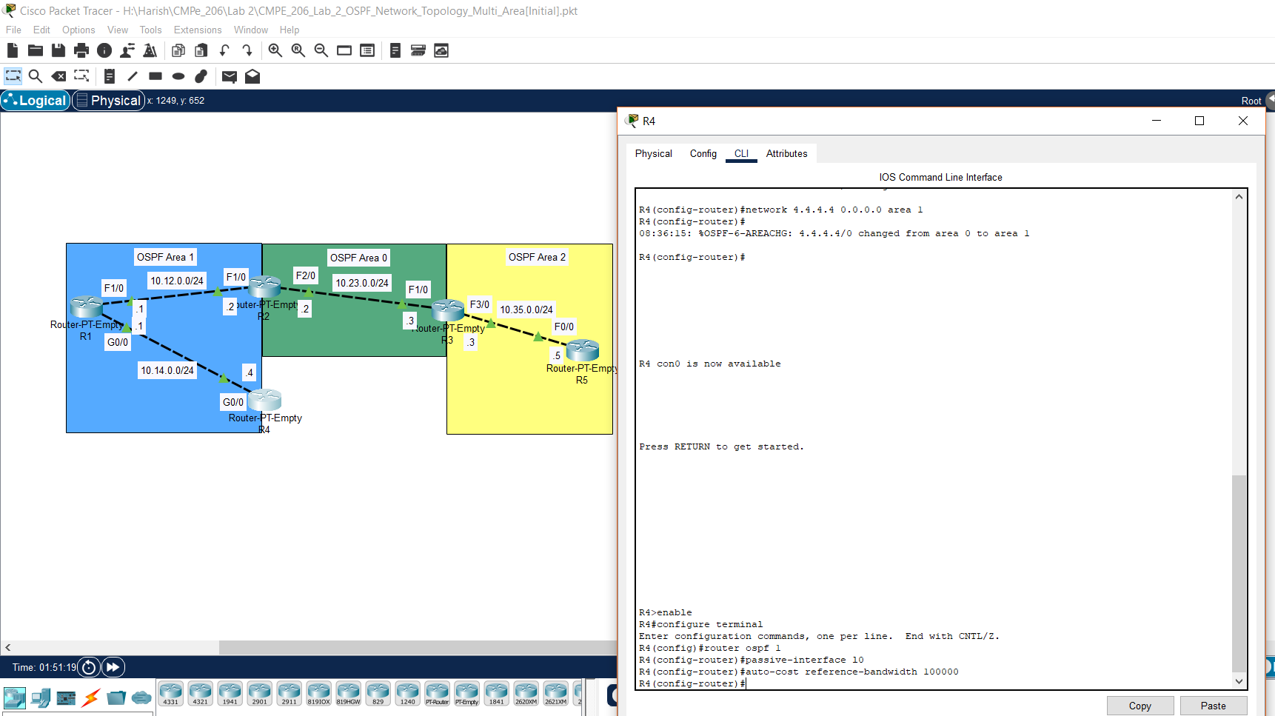

j. Screenshot of R5 for turning loopback interface from active to passive and configuring the proper bandwidth number.

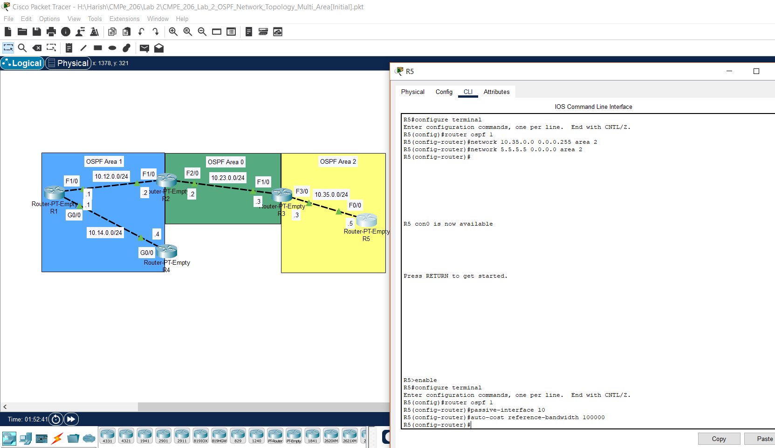

k. Screenshot of R1 to examine its current OSPF neighbor and route information.

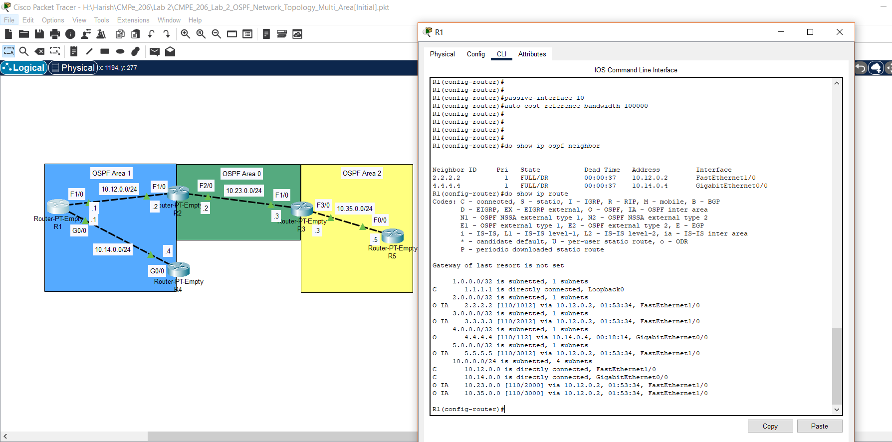

l. Screenshot of R2 to examine its current OSPF neighbor and route information.

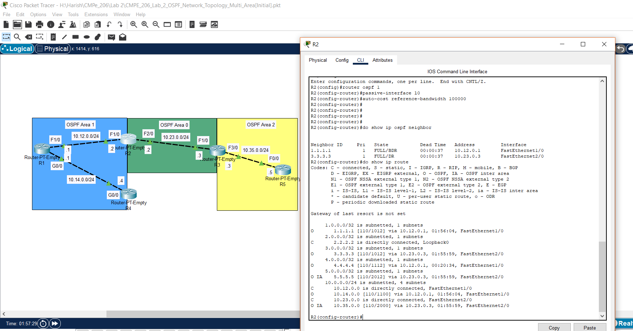

m. Screenshot of R3 to examine its current OSPF neighbor and route information.

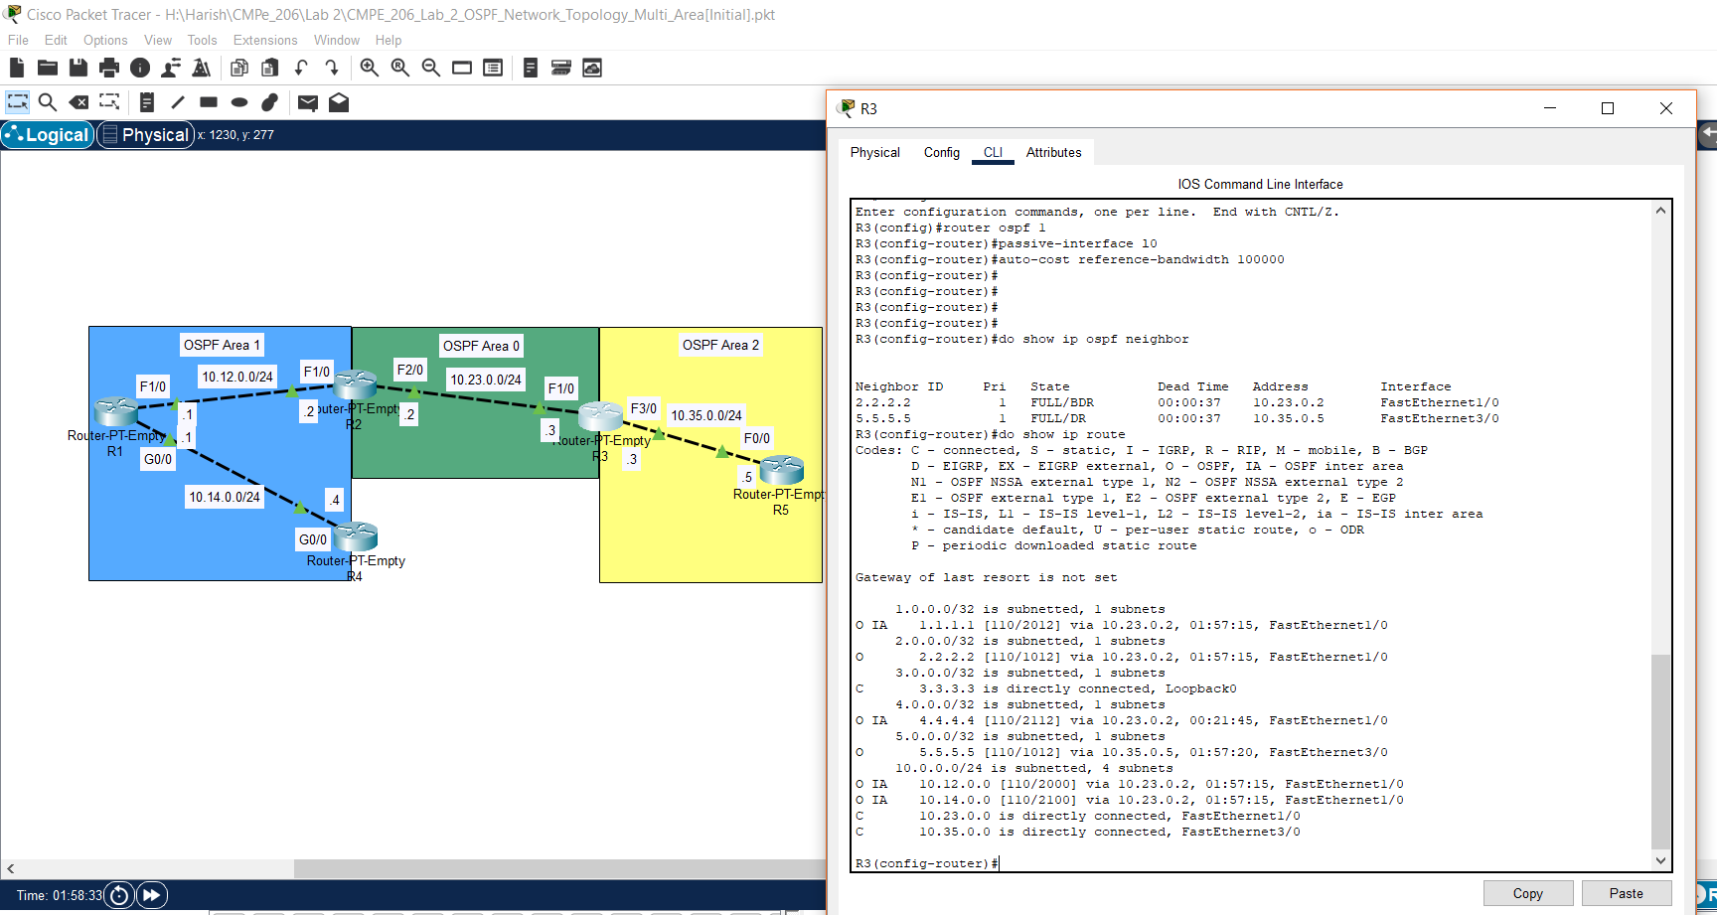

n. Screenshot of R4 to examine its current OSPF neighbor and route information.

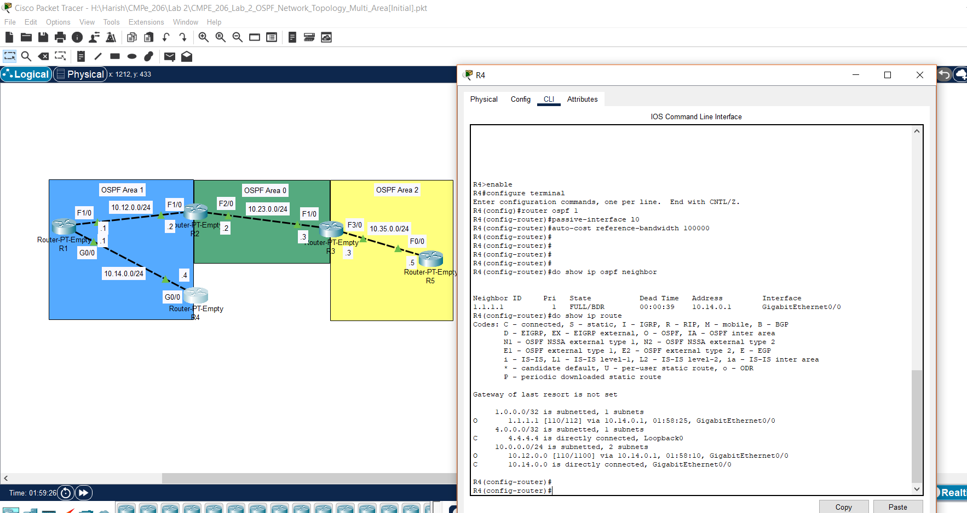

o. Screenshot of R5 to examine its current OSPF neighbor and route information.

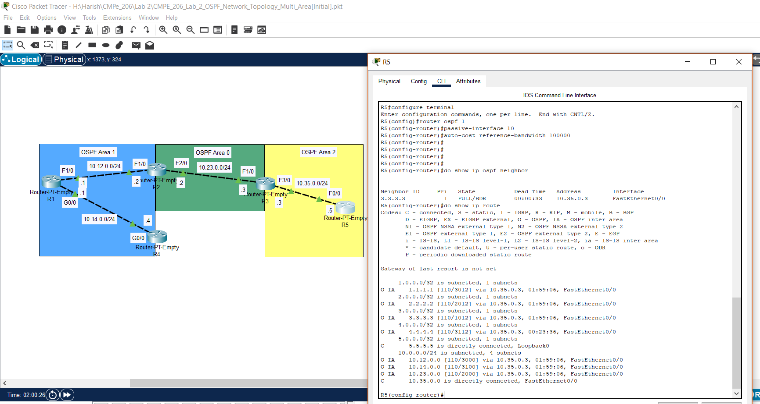

**Task 8: Configure Area Border Router with Router Summarization:**

Performed all the steps for configuring area border router with router summarization.

a. Screenshot of performing route summarization on R2 to optimize the LSDB of R1 and R4.

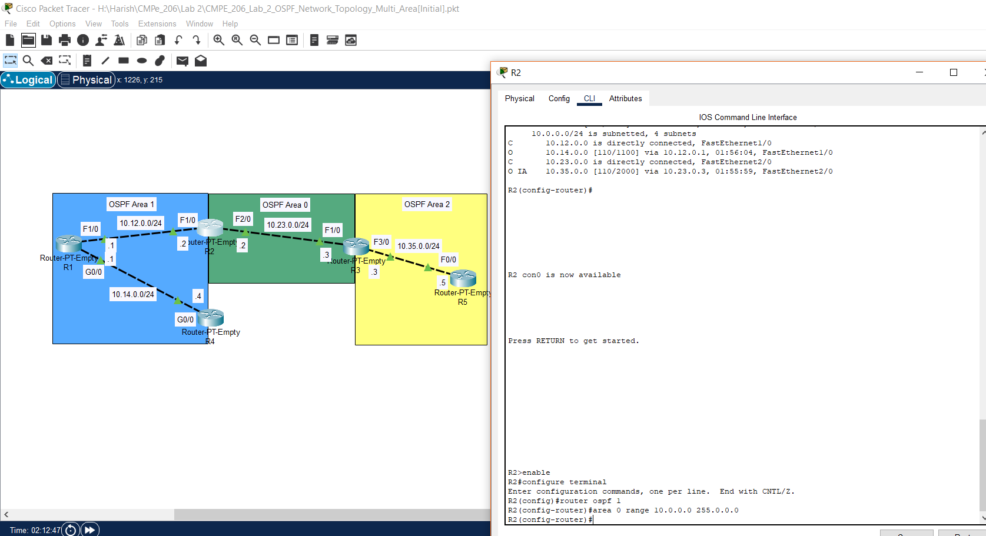

b. Screenshot of performing route summarization on R3 to optimize the LSDB of R5.

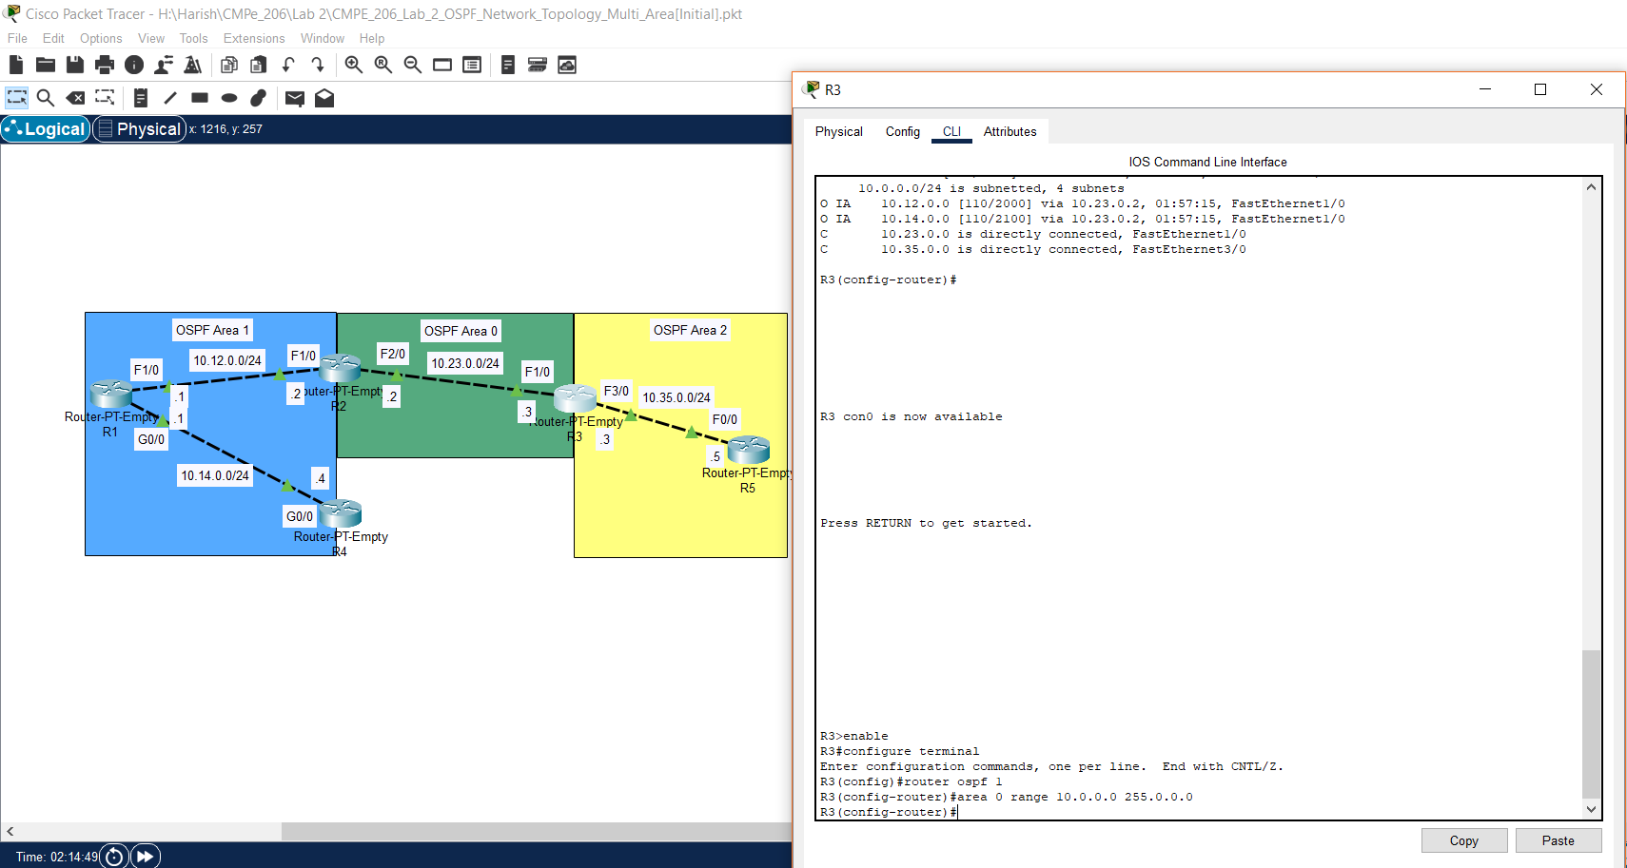

c. Screenshot for examining the routing table on R1 to see if the routing information has been summarized.

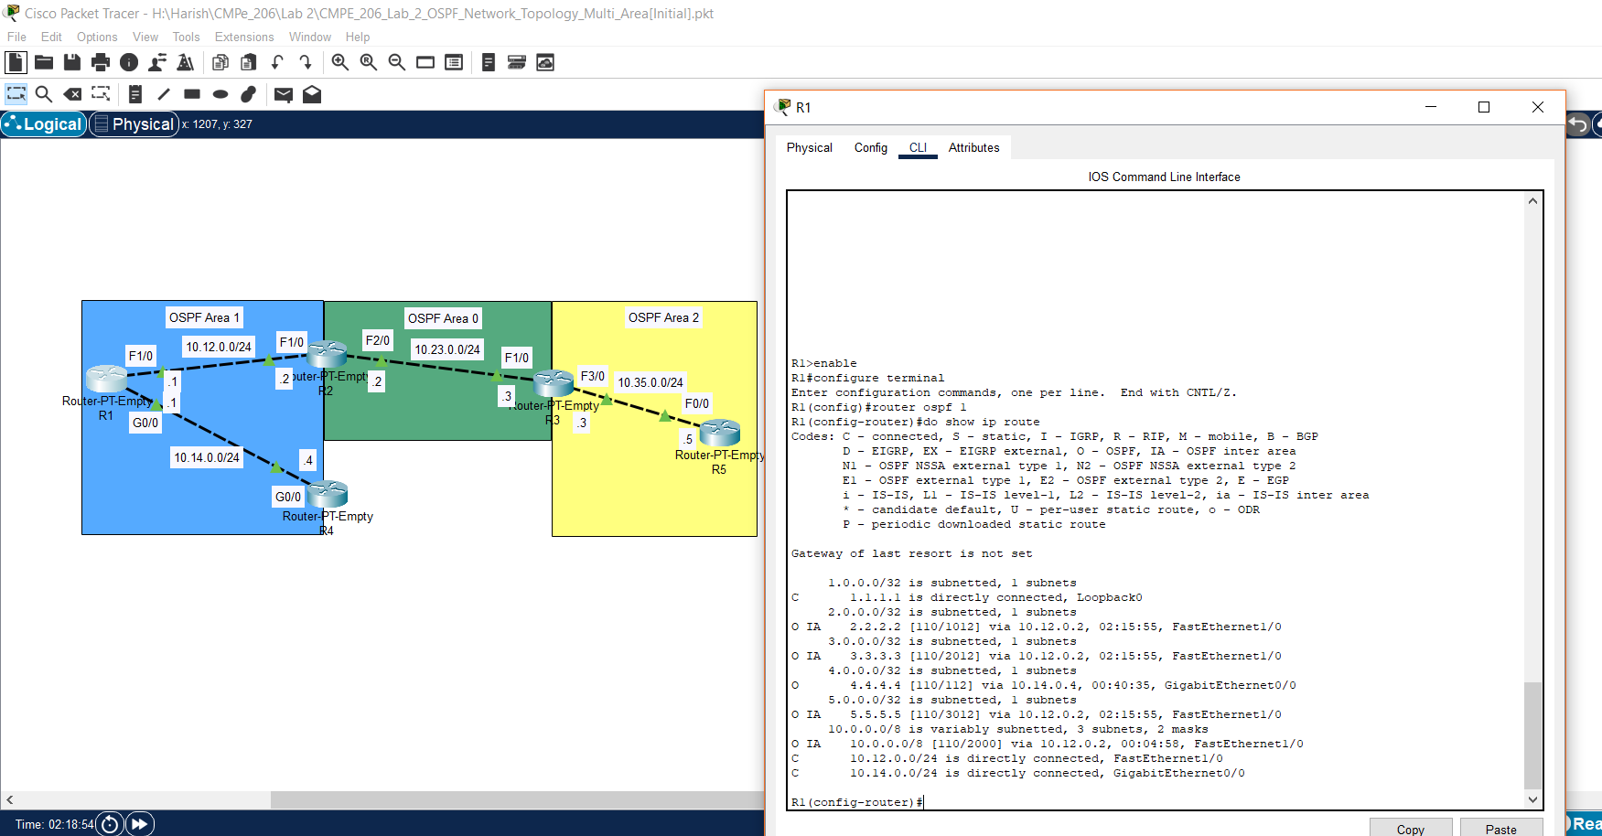

d. Screenshot for examining the routing table on R3 to see if the routing information has been summarized.

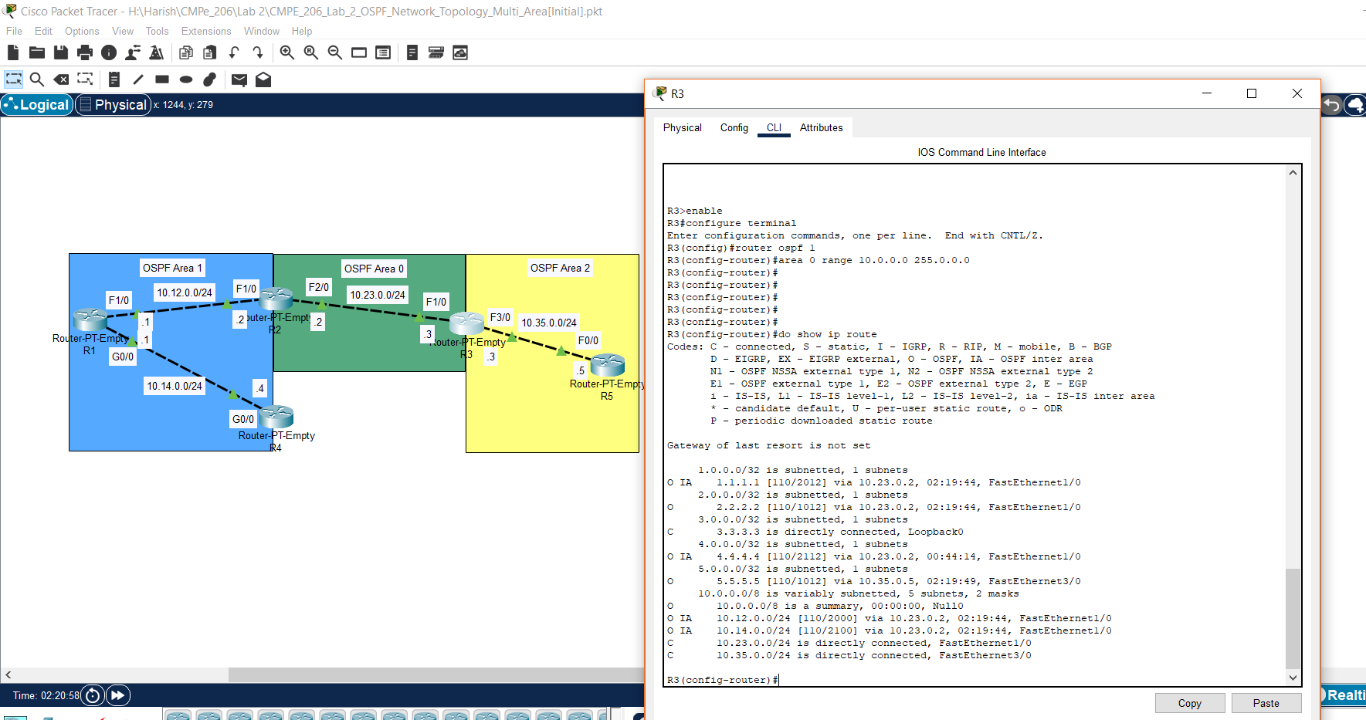

e. Screenshot for examining the routing table on R5 to see if the routing information has been summarized.

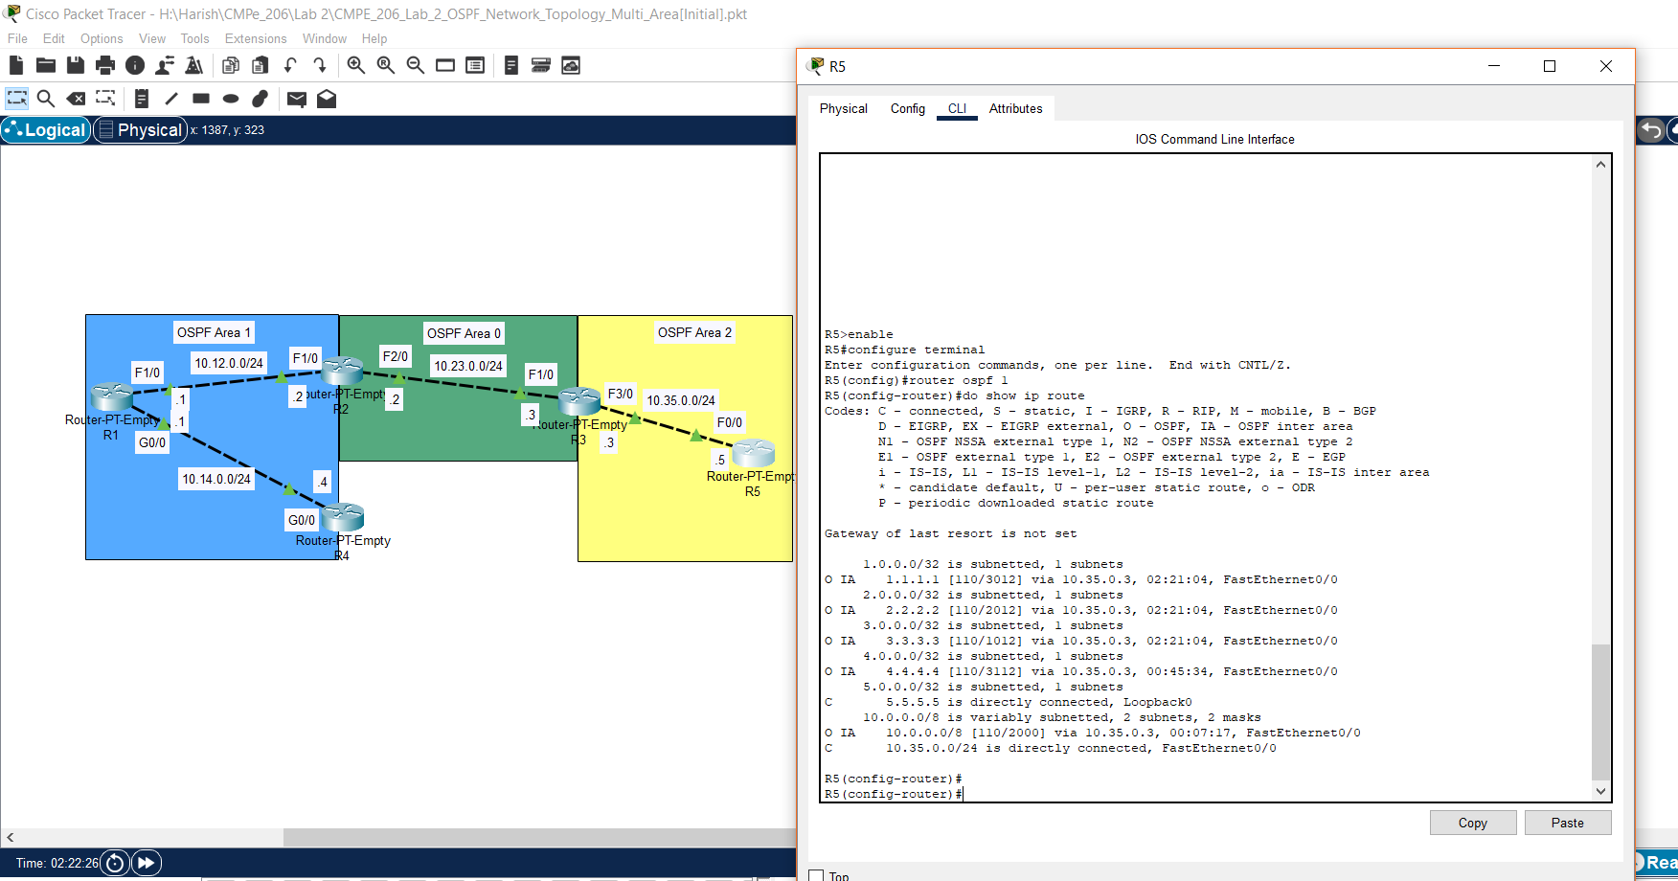

From the above screenshots, it can be seen that the routes have been summarized and the RAM of IRs in a large network can be released for other information storage activities.

**9. Conclusion:**

From this lab, I:

1. Understood the Mechanism of Link-State Routing Protocol Open Shortest Path First (OSPF).
2. Learned how to Configure Router with Loopback Address.
3. Learned how to Configure Router with OSPF and LSAs Message Sending.
4. Learned how to Configure Router with OSPF LSAs Message Suppression.
5. Learned how to Configure Router with OSPF Reference Bandwidth.
6. Learned how to Configure Router with OSPF Route Cost on Interfaces.
7. Learned how to Configure Router in OSPF Multi-Area Environment.
8. Learned how to Configure Area Border Router with Route Summarization.